LAB FPGA platform Hardware

The FPGA portion of the experimental platform designed for the HPED Lab exercises is designed to handle all real-time hardware interfacing tasks and exposes a high level memory mapped interface to the code running on the ARM cores.
The overall structure of the FPGA implemented logic, shown in the figure below, consists of a series of peripherals connected to the ARM core clusters (Both cortex A53 and R5) with an AMBA AXI bus. Analog data sensing for the DC and AC side is handled by two identical logic pipelines composed of the following:
- CONVERSION CONTROL TIMER: Simple 16 Bit timer running at a fixed 100MHz clock frequency that can be used to control sampling frequency and phase
- ADC SPI INTERFACE: A multichannel SPI interface capable of simultaneously reading the connected ADC sensorS:
- ADC POST-PROCESSING: Post processing block capable of offset correction, filtering averaging and decimation.
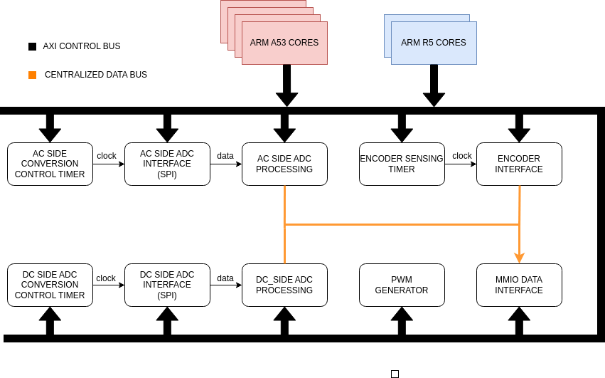
Rotor sensing is handled directly in FPGA with both speed and angle being directly measured from the incremental encoder signal. The first is done through counting of both rising and falling edges of both A and B signals. Shaft speed is independently digitized by measuring the period of the A signal, thus avoiding the need for digital differentiation (which is prone to noise amplification)
Finally an advanced PWM generator can be used to produce the desired output gating signals.
Each peripheral is directly mapped in the address space of the ARM cores, thus the control register can be accessed by reading and writing to the correct memory address. Each peripheral occupies a contiguous block of addresses starting from the base address from the table below.
Peripheral | Peripheral type | Base address | Number of registers
PWM GENERATOR | PWM GENERATOR | 0xA0000000 | 18
GLOBAL CONTROL | GPIO | 0xA0010000 | 2
AC SIDE TIMER | ENABLE GENERATOR | 0xA0020000 | 4
DC SIDE TIMER | ENABLE GENERATOR | 0xA0030000 | 4
AC SIDE SPI | SPI ADC INTERFACE | 0xA0040000 | 4
DC SIDE SPI | SPI ADC INTERFACE | 0xA0050000 | 4
AC SIDE PROCESSING | ADC PROCESSING | 0xA0060000 | 13
DC SIDE PROCESSING | ADC PROCESSING | 0xA0070000 | 13
ENCODER INTERFACE | ENCODER INTERFACE | 0xA0080000 | 4
ENCODER TIMER | ENABLE GENERATOR | 0xA0090000 | 5
MMIO DATA | MEMORY | 0xA00A0000 | 10
IRQ CONTROLLER | IRQ CONTROLLER | 0xA00B0000 | 1

how the peripherals structure and register maps.

PWM GENERATOR
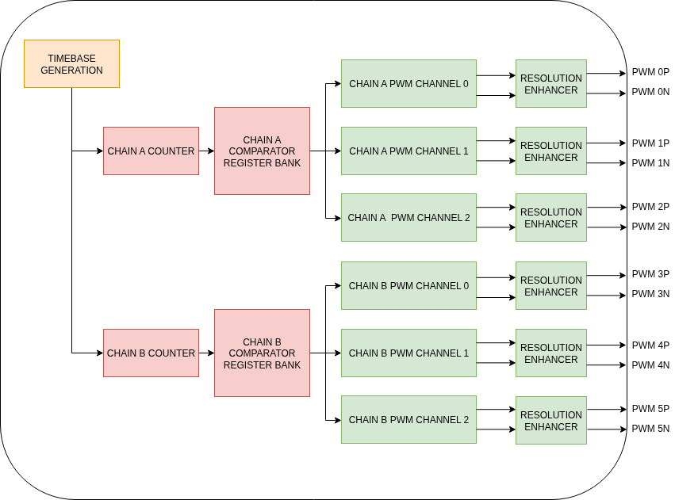

This peripheral is a highly capable PWM modulator that supports many advanced carrier based modulation techniques. It can be configured to generate carriers each one has an associated bank of compare registers that can handle up to modulating signals generating pwm channels.

Other advanced features of this modulator are:
- Dynamically configurable phase shift between carriers
- Automatic deadtime insertion
- Configurable default pin state
- Asymmetric pwm capability
- multiphase edge shifter for enhanced resolution.
- Selectable and delayable synchronization out event

The address map for this peripheral is divided in a first block of global registers controlling the behavior of the module as a whole, and number of subsequent blocks to manage each pwm chain separately
Register Name | Description | Offset | Interlocking
Global control | - Bit[0:2]: PWM timebase frequency divisor  - Bit 3: Timebase enable  - Bit 4: External timebase enable  - Bit 5: Enable all counters  - Bit 6: Instant counter reload (used in distributed system synchronization)  - bit[7:17] default pin state | 0 | NO
Sync Out select | Chain used to generate the output synchronization signal | 0x4 | NO
Sync out delay | Delay between counter reload and sync event generation | 0x8 | NO

The first pwm chains is controlled through the following registers:
Register Name | Description | Offset | Interlocking
Threshold low[0] | Value of the comparator low treshold for channel 0 | 0x100 | NO
Threshold low[1] | Value of the comparator low treshold for channel 1 | 0x104 | NO
Threshold low[2] | Value of the comparator low treshold for channel 2 | 0x108 | NO
Threshold high[0] | Value of the comparator high threshold for channel 0 | 0x10C | NO
Threshold high[1] | Value of the comparator high threshold for channel 1 | 0x110 | NO
Threshold high[2] | Value of the comparator high threshold for channel 2 | 0x114 | NO
deadtime[0] | Deadtime for channel 0 | 0x118 | YES
deadtime[1] | Deadtime for channel 1 | 0x11C | YES
deadtime[2] | Deadtime for channel 2 | 0x120 | YES
Carrier low | Lower value of the carrier waveform | 0x124 | YES
Carrier high | Higher value of the carrier waveform | 0x128 | YES
Carrier phase | Phase of the carrier | 0x12C | NO
Output enable | - Bit[0:1]: Enable channel 0P and 0N gates  - Bit[2:3]: Enable channel 1P and 1N gates  - Bit[4:5]: Enable channel 2P and 2N gates | 0x130 | YES
Deadtime enable | - Bit 0: Enable deadtime insertion for channel 0  - Bit 1: Enable deadtime insertion for channel 1  - Bit 2: Enable deadtime insertion for channel 2 | 0x134 | YES
Control | - Counter mode selection:  - 0: up counters  - 1: down counter  - 2: up-down counter | 0x138 | YES

Each subsequent chain starts at multiples of 0x100 (e.g. chain #1 starts at 0x100, chain #2 starts at 0x200, etc.)
This peripheral can generate a pwm signal using either a sawtooth (up count) or triangular (up-down count). The threshold registers are used to control the output signal state as shown in the following diagrams.
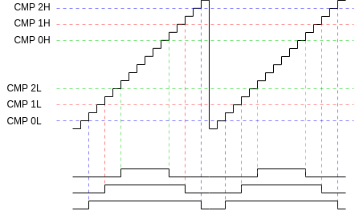
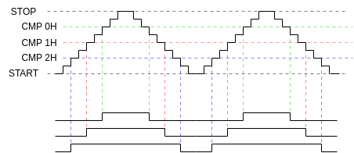

To reduce the chances of spurious transitions when the PWM counters are running, some configuration registers are interlocked at the hardware level and any configuration change will be ignored. They should be configured before starting the counters.
The pwm generator outputs a synchronization pulse upon counter reload, this is used to trigger the pwm reload interrupt

PWM generation workflow

- Enable timebase in global control register
- Load desired PWM parameters
- enable counters in Global control register

ENABLE GENERATOR
This peripheral can generate one or more enable pulses that are used throughout the whole FPGA each generator consists of a single 32 bit timer setting the event frequency and a bank of comparators, which fires the appropriate enable pulse each time the counter value crosses a threshold, ths controlling the relative phase of the output signals.
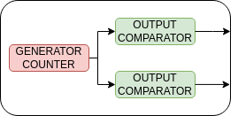

Register Name | Description | Offset
enable | 0: generator disabled  1: generator enabled | 0
Period | Period of the outputs (in clock cycles) | 0x4
Threshold [0] | Phase of Enable 0 with respect to counter reload (in clock cycles) | 0x8
Threshold [1] | Phase of Enable 1 with respect to counter reload (in clock cycles) | 0xC

The internal waveforms of the modules are as follows
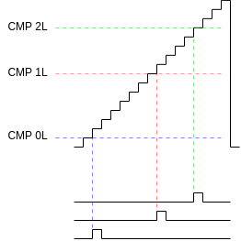

SPI ADC INTERFACE

This peripheral implements a multichannel interface capable of reading the sample data from a bank of external SPI interfaced ADCs. To reduce resource usage, only a single the serial clock (SCLK) and chip select line are used, enforcing fully simultaneous sampling. Each SPI channel is served by its own shift register allowing for fully parallel data input and output on the MISO and MOSI signals.
Eachydata transfer cycle is automatically started by a logic signal sent by the relevant timebase module.
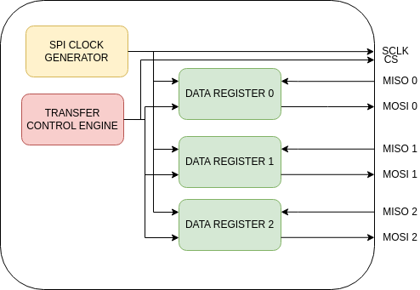

Register Name | Description | Offset
Control | Bit 0: deprecated  Bit [1:3]: SCLK divider setting  Bit [4:7]: RESERVED  Bit 8: Deprecated  Bit 9: Shift direction ( 0 MSB first, 1 LSB fist)  Bit [10:12]: Deprecated  Bit 13: CS polarity  Bit 14: RESERVED  Bit 15: RESERVED  Bit 16: Select shift register latching edge ( 0 rising edge, 1 falling edge) CPHA  Bit 17: Clock polarity CPOL (0 for active high 1 for active low) | 0
cs_delay | Delay (in clock cycles) between chip select assertion and transfer start | 0x4
Reserved | Do not write here | 0x8
Trigger | Writing to this register will trigger an SPI transfer cycle | 0xC

ENCODER INTERFACE
This peripheral handles automatically the acquisition of motor shaft speed and angle through an incremental encoder.
Register Name | Description | Offset
Angle address | Address of the angle data on the output bus (write 0 to this) | 0
Speed address | Address of the speed data on the output bus (write 1 to this) | 0x4
Encoder pulses | Number of encoder edges per encoder revolution | 0x8
Angle out | Read current angle value | 0xC
Speed out | Read current speed value | 0x10
Index tracking enable | Write 1 to enable encoder index tracking | 0x14

GLOBAL CONTROL
This GPIO peripheral allow read and write access to a 32 bit word containing flags that manage the global state of the FPGA based logic:
Flag name | Description | Bit
DC sensing enable | Enable sensing DC voltages and currents (also mapped to user led B) | 0
AC sensing enable | Enable sensing AC currents and voltages (also mapped to user led A) | 1
Gates enable | Enable the pwm modulation | 2

MMIO DATA AREA
In this area the DATA from the sensors will be deposited in this memory area.
Register Name | Description | Offset
Angle | Encoder Angle | 0
Speed | Encoder Speed | 0x4
ac_ia | AC side current of phase A | 0x8
ac_ib | AC side current of phase B | 0xC
ac_ic | AC side current of phase C | 0x10
ac_va | AC side voltage on phase A | 0x14
ac_vb | AC side voltage on phase B | 0x18
ac_vc | AC side voltage on phase C | 0x1C
dc_v | DC side voltage | 0x20
dc_i | DC side current | 0x24

PMOD SIGNALS

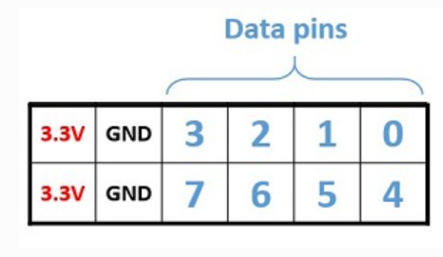
The following signals internal to the FPGA are mirrored on the PMOD connector to facilitate debug and application development

PIN | Signal
0 | DC side SPI SCLK
1 | DC side SPI SS
2 | AC side SPI SCLK
3 | AC side SPI SS
4 | DC side SPI DATA (voltage)
5 | DC side SPI DATA (A phase current)
6 | DC side SPI DATA (B phase current)
7 | PWM SYNC

